**Task 1: Check if a Number is Even or Odd**

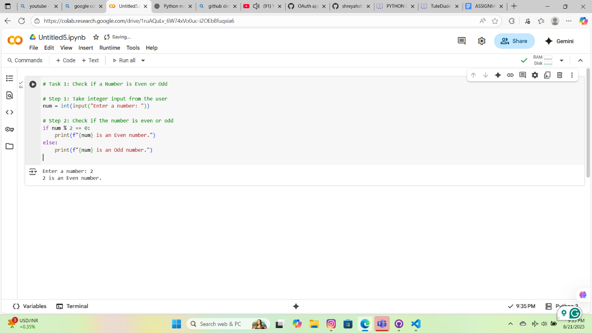

**Task 2: Sum of Integers from 1 to 50 Using a Loop**

